Project Proposal Template
Agentic AI Applications Course

Team Number:
Team Member Name (s): Aditya Pandey, Konathala Ishaan Karthikeya
Proposed Project Title: Nestify — Autonomous Multi-Agent DevOps System

1. Problem Statement & Use Case: Your problem statement should answer the following questions clearly:
- What real-world problem are you solving?

- Deploying applications using Docker is difficult for non-developers. Writing Dockerfiles, managing environment variables, fixing YAML errors, and deploying to cloud platforms require DevOps expertise.

- Who is the target user / beneficiary?

- Students, indie hackers, freelancers, and small teams without DevOps engineers.

- What currently happens (manual process, existing tools, pain points)?

- Copy-paste templates don’t match real code
- Docker errors are hard to understand
- No automatic security validation
- No monitoring after deployment
- Automatic Deployment Not available, User needs knowledge.

- Why is this a good fit for an agentic AI solution (vs a simple LLM prompt / RAG chatbot?)
- The system must analyze real code, plan architecture, generate multiple interdependent files, validate security, deploy, and monitor continuously.
A single LLM call cannot handle multi-step reasoning, validation, and reflection.

2. Justify that your application is Agentic?
Explain why your application needs autonomy, iteration, tools, planning, reflection, and/or multi-agent collaboration
Core Agentic Capabilities:
- Tool use (file parsing, Docker logic)
- Planning & task decomposition
- Reflection (Meta Agent review)
- Multi-agent coordination
- Iterative validation
If Built as Single LLM:
No cross-file consistency, no validation loop, no structured pipeline, high error rate.
Expected Behavior Example:
Code Analyzer detects database → Planner adds service → Dockerfile generated → Security Agent flags issue → Meta Agent rechecks → Final validated output delivered.

3. High-Level Solution Overview
Nestify is a 12-agent pipeline system.
Main Agents:
- Code Analyzer
- Planner
- Dockerfile Writer
- Compose Builder
- Config Agent
- Security Agent
- Meta Agent
- Explainer
- Debug Agent
- Deploy Agent
- Self-Healing Agent
- Token Governor
Flow:
Upload Code → Analyze → Plan → Generate Files → Validate → Explain → Deploy → Monitor

Here is an example diagram:
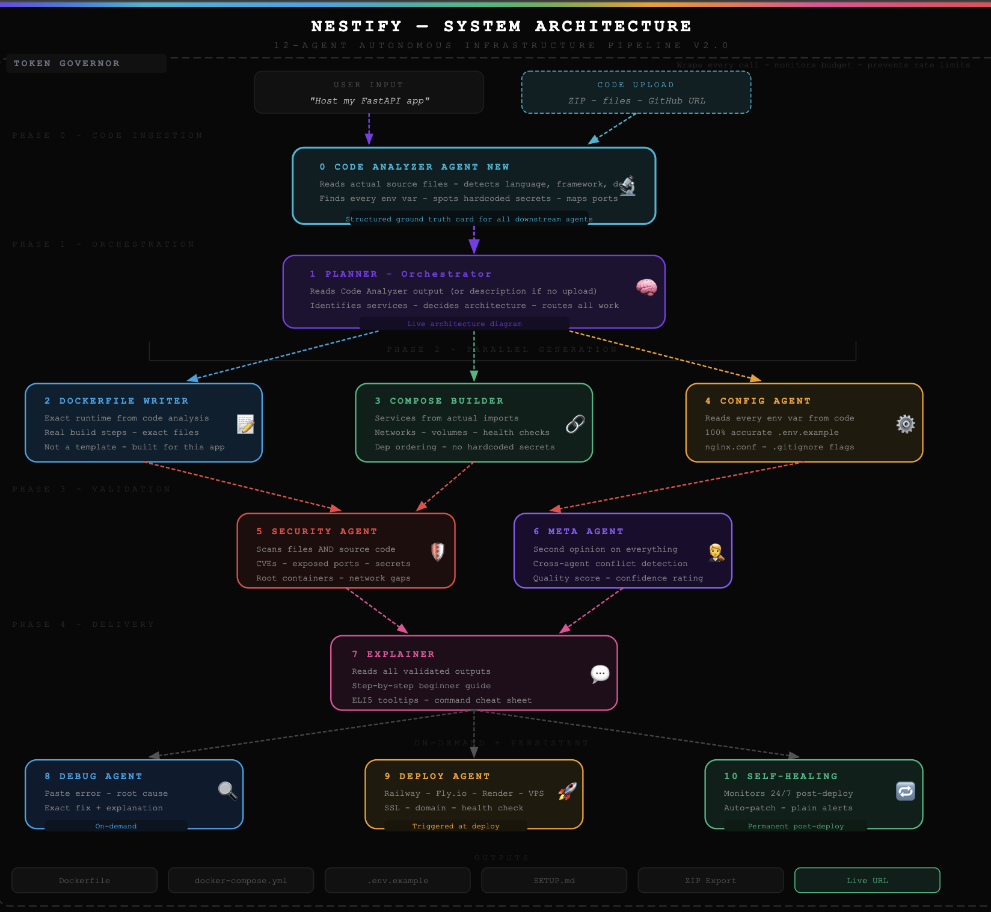

4. Proposed Technology Stack
LLMs (All Free):
- Llama 3 8B Instruct (reasoning agents)
- CodeLlama 7B Instruct (code generation agents)
Framework: Custom multi-agent orchestration (Python)
Frontend: React
Backend: Node.js
Monitoring: Rule-based + LLM diagnosis
Deployment Target: Railway / Fly.io / VPS
Storage: SQLite (MVP level)

5. Success Metrics & Evaluation Plan (≈ ½ page)
Quantitative:
- ≥ 80% correct Docker setup generation
- ≤ 30 seconds average generation time
- ≥ 15 test applications evaluated
Qualitative:
- Security issues correctly flagged
- User rating ≥ 4/5 (peer testing)
- Clear, beginner-friendly explanations
Failure Modes:
- Incorrect YAML formatting
- Missing environment variables
- Logical architecture mismatch
Measured via structured test cases.

6. Risks, Challenges & Mitigation Plan
• Hallucinated configurations → Meta Agent validation
• Syntax errors → CodeLlama for strict generation
• Infinite loops → Iteration limits
• High compute cost → Token Governor

7. Timeline & Milestones
Demo 1:
Single-agent prototype with Dockerfile generation
Demo 2:
Multi-agent pipeline + validation layer
Final Submission:
Full 12-agent MVP + deployment simulation + evaluation report

